System Architecture : calendar

1.Major module

Calendar

1) When the date is clicked, the saved schedule is output through the text view

2) Can move to previous month and next month by clicking button.

Save Schedule

1) Click the Save Schedule button to pop up a window to save the schedule

2) YES button : After receiving the text value, leave the log and close the event

3) NO button : End event on click

4) Schedule input text window: Part of entering schedule

2.Interfaces between modules

Class diagram

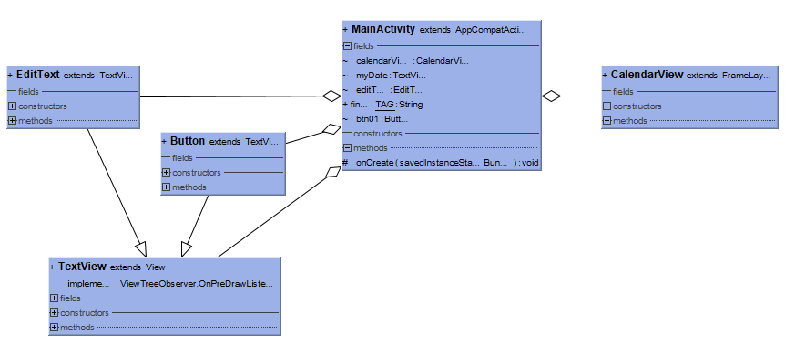

Sequence diagram



Click save schedule button

Enter schedule

Click the date

Search for saved schedules

Stored schedule output

Save schedule

View schedule

Android

Application

Database

3.data description

|  |  |  |
| --- | --- | --- |
| Data item | Data type | Description |
| schedule | string | Schedule contents |
| date | int |  |

4.Pros and cons

If you show the schedule through Textview, it is simple and you can see the schedule with the calendar, but if you exceed the number of characters, you have to scroll

5.Risk assessment

Due to the drawback of scheduling via Textview, I tried to pop up a window showing the schedule when I clicked the date, but I could not solve it.

6.test plan

|  |  |  |
| --- | --- | --- |
| Screen | Function | Detailed function |
| calendar | can see calendars and schedules. | Screen for confirming or saving saved schedule |
| Save Schedule | can save the schedule | When a user enters a schedule, a screen for saving the schedule to the server |

|  |  |
| --- | --- |
| Test description | Feature to be tested |
| Enter the schedule through the Save Schedule screen and verify that the data is stored well on the server | Save Schedule,  database |
| I'll see if the schedule stored on the server is output to the calendar. | calendar |